**"TO DEMONSTRATE THAT THE ARITHMETIC MEAN OF TWO DIFFERENT POSITIVE NUMBER IS ALWAYS GREATER THAN THE GEOMETRIC MEAN"**

**A PROJECT WORK SUBMITTED FOR THE PARTIAL FULFILLMENT OF THE REQUIREMENT FOR THE GRADE 11 SCIENCE IN MATHS**

**By**

**Name:**

**Grade:**

**Roll No:**



**National Academy of Science and Technology(NAST)**

**National Education Board(NEB)**

**Dhangadhi, Kailali, Nepal**

**Date:**

**CERTIFICATE OF APPROVAL**

The project work entitled "TO DEMONSTRATE THAT THE ARITHMETIC MEAN OF TWO DIFFERENT POSITIVE NUMBER IS ALWAYS GREATER THAN THE GEOMETRIC MEAN" by Mr. __________________________ under the supervision of_Mr._________________________Of______________________________________________________________________, Nepal, is hereby submitted for the partial fulfillment of requirement of Maths in Grade 11. This project work has not been submitted in any other school or institution previously for the award of Grade 11.

__________________________________________ __________________________________________

Supervisor: Head of the Department:

**Mr. Khem Raj Pandey Mr. Krishna Singh Bhandari**

Department of Maths Department of Science

National Academy of Science National Academy of Science

and Technology(NAST) and Technology(NAST)

**DECLARATION**

I, ­­­­­­­­­­­­___________________ hereby declare that the project work entitled, "TO DEMONSTRATE THAT THE ARITHMETIC MEAN OF TWO DIFFERENT POSITIVE NUMBER IS ALWAYS GREATER THAN THE GEOMETRIC MEAN " under_the_supervision_of_Mr.________________________Of____________________________________________________________________________ , Nepal, presented herein is genuine work done originally by me and has not been published or submitted elsewhere for the requirement of any degree program. Any literature, data or works done by others and cited in this project work has been given due acknowledgement and listed in the reference section.

_______________________

Grade:

E-mail address:

Date:

**TABLE OF CONTENTS**

**Chapter 1: Introduction**

**Chapter 2: Motivation**

**Chapter 3: Materials Required**

**Chapter 4: Objective**

**Chapter 5: Method of Construction**

**Chapter 6: Demonstration**

**Chapter 7: Observation**

**Chapter 8: Literature Review**

**Chapter 9: Conclusion**

**Chapter 10: Acknowledgement**

**Chapter 11: References**

1. **Introduction:-**

In Mathematics, the **Arithmetic Mean** is simply the mean or average for a set of data or a collection of numbers. In mathematics, we deal with different types of means such as arithmetic mean, arithmetic harmonic mean, geometric mean and geometric harmonic mean.

The term Arithmetic Mean is just used to differentiate it from the other “means” such as harmonic and geometric mean. The arithmetic mean is a good average. It is sometimes known as average. But, it cannot be used in some cases like, the distribution has open end classes, the distribution is highly skewed, averages are taken for ratios and percentages.

Formula for A.M. between two numbers= (a + b)/2

In Mathematics, the **Geometric Mean (GM)** is the average value or mean which signifies the central tendency of the set of numbers by finding the product of their values. Basically, we multiply the numbers altogether and take the nth root of the multiplied numbers, where n is the total number of data values. For example: for a given set of two numbers such as 3 and 1, the geometric mean is equal to √(3×1) = √3 = 1.732.

In other words, the geometric mean is defined as the nth root of the product of n numbers. It is noted that the geometric mean is different from the arithmetic mean. Because, in arithmetic mean, we add the data values and then divide it by the total number of values. But in geometric mean, we multiply the given data values and then take the root with the radical index for the total number of data values. For example, if we have two data, take the square root, or if we have three data, then take the cube root, or else if we have four data values, then take the 4th root, and so on.

Formula for G.M. between two numbers= (a*b) ^ (1/2)

1. **Motivation:-**

The arithmetic mean is one of the oldest methods used to combine observations in order to give a unique approximate value. It appears to have been first used by Babylonian astronomers in the third century BC. The arithmetic mean was used by the astronomers to determine the positions of the sun, the moon and the planets. According to Plackett (1958), the concept of the arithmetic mean originated from the Greek astronomer Hipparchus.

In 1755 Thomas Simpson officially proposed the use of the arithmetic mean in a letter to the President of the Royal Society.

1. **Materials Required:-**

* Coloured Chart Paper
* Ruler or scale
* Sketch Pens
* Cutter

1. **Objective:-**

This project is useful to understand the relationship between Arithmetic and Geometric means.

To show AM > GM for any two different positive numbers.

1. **Method of Construction:-**

* From chart paper, cut off four rectangular pieces of dimensions a*b (a>b).
* Arrange the four rectangular pieces as shown in figure below.

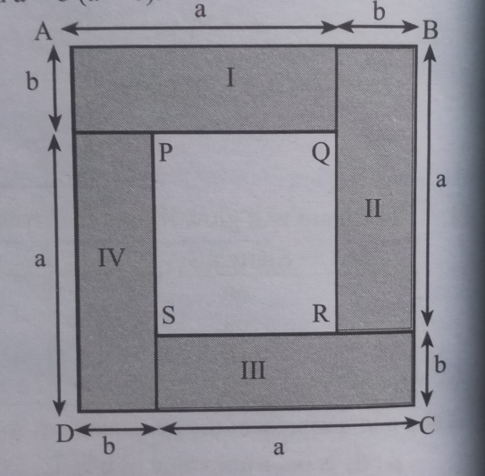

**Fig. Apparatus to test AM > GM**

1. **Demonstration:-**
2. ABCD is a square of side (a + b) units.
3. Area of ABCD= (a + b)^2 sq. units.
4. Area of four rectangular pieces= 4*(a*b)= 4ab sq. units.
5. PQRS is a square of side (a – b) units.
6. Area ABCD= sum of the areas of four rectangular pieces + Area of square PQRS.

∴ Area of ABCD > sum of the areas of four rectangular pieces.

i.e. (a + b)^2 > 4ab

or, ((a + b)/2)^2 > ab

∴ (a + b)/2 > (a*b)^(1/2)

i.e., AM > GM.

1. **Observation:-**

Take a= 3cm, b= 2 cm

∴ AB= a + b= 5 units

Area of ABCD= (a + b)^2= 25 sq. units

Area of each rectangle= ab= 6 sq. units

Area of square PQRS= (a - b)^2= 1 sq. units

Area of ABCD= 4(Area of rectangular pieces) + Area of square PQRS

⇒ Area of ABCD > 4(Area of rectangular pieces)

or, 25 sq. units > 4*6 sq. units

or, 25 sq. units > 24 sq. units

i.e. AM > GM

1. **Literature Review:-**

The **arithmetic mean** is the most commonly used type of [mean](https://www.scribbr.com/statistics/mean/) and is often referred to simply as “the mean.” While the arithmetic mean is based on adding and dividing values, the [**geometric mean**](https://www.scribbr.com/statistics/geometric-mean/) multiplies and finds the root of values.

Even though the geometric mean is a less common [measure of central tendency](https://www.scribbr.com/statistics/central-tendency/), it’s more accurate than the arithmetic mean for percentage change and positively skewed data. The geometric mean is often reported for financial indices and population growth rates.

The arithmetic mean is used by statisticians but for data sets with no significant outliers. This type of mean is useful for reading temperatures. It is also helpful in determining the average speed of the car. On the other hand, the geometric mean is useful in cases where the dataset is logarithmic or varies by multiples of 10.

The geometric mean is appropriate for percentage changes, volatile numbers, and correlation data, especially [**investment portfolios**](https://www.wallstreetmojo.com/portfolio-investment/). Most financial returns correlate with stocks, bond yield, and premiums. The longer period makes the compounding effect more critical and hence the use of a geometric mean. While for independent data sets, arithmetic means is more appropriate as it is simple to use and easy to understand.

1. **Conclusion:-**

Hence, Arithmetic mean between two unequal positive numbers is greater than Geometric mean.

From this experiment, we get to learn about the definition, formula and uses of arithmetic means and geometric means. The uses of these kinds of means have been spread from scientific research to census reports.

1. **Acknowledgement:-**

I would like to express my special thanks of gratitude to my teacher Mr. _________________­­­­_____________ as well as our principal Mr. _________________________________ who gave us the golden opportunity to do this wonderful project on the topic “TO DEMONSTRATE THAT THE ARITHMETIC MEAN OF TWO DIFFERENT POSITIVE NUMBER IS ALWAYS GREATER THAN THE GEOMETRIC MEAN”, which also helped me in doing a lot of research and I came to know about so many new things I am really thankful to them.

Secondly, I would like to thank my parents and friends who helped me a lot in finalizing this project within the limited time frame.

1. **References:-**

* Pioneer Mathematics-I(Grade XI),Dreamland Publication by Mr. Gopal Neupane
* [www.wikipedia.com](http://www.wikipedia.com)
* [www.byjus.com](http://www.byjus.com)